PS C:\windows\system32> #Let's login, may launch a browser to authenticate the session.

Connect-AzAccount -SubscriptionName 'Visual Studio Enterprise Subscription'

Connect-AzAccount : The term 'Connect-AzAccount' is not recognized as the name of a cmdlet, function, script file, or operable

program. Check the spelling of the name, or if a path was included, verify that the path is correct and try again.

At line:2 char:1

+ Connect-AzAccount -SubscriptionName 'Visual Studio Enterprise Subscri ...

+ ~~~~~~~~~~~~~~~~~

+ CategoryInfo : ObjectNotFound: (Connect-AzAccount:String) [], CommandNotFoundException

+ FullyQualifiedErrorId : CommandNotFoundException

<https://github.com/Azure/azure-powershell>

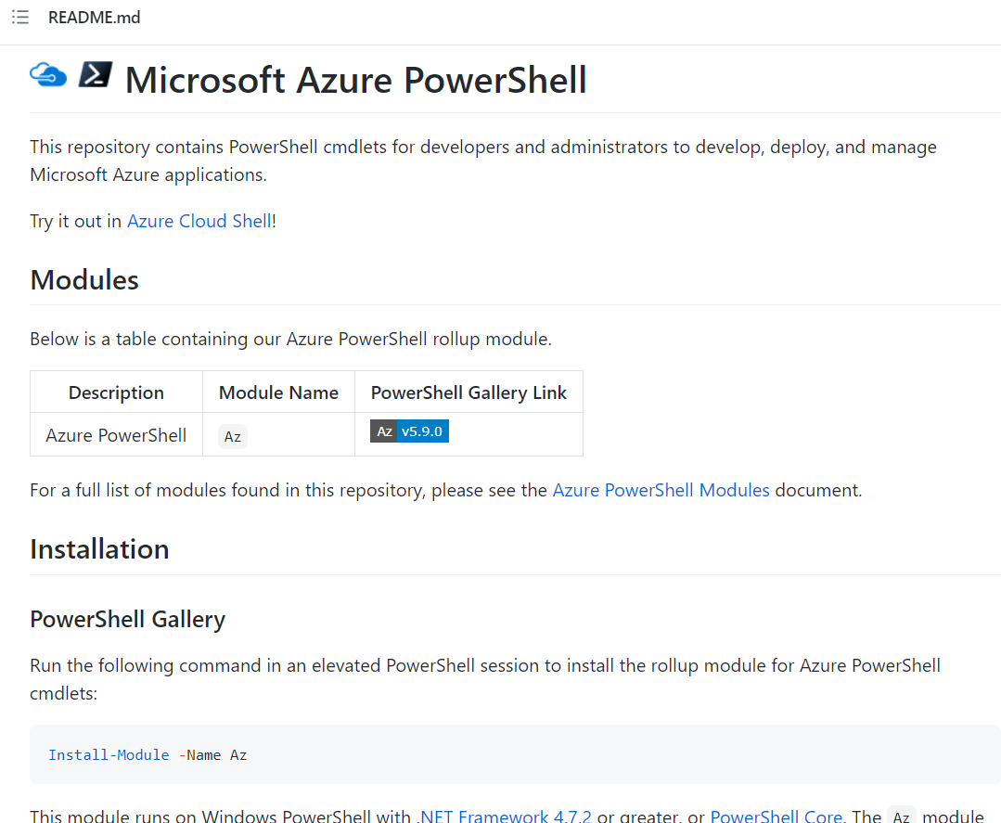







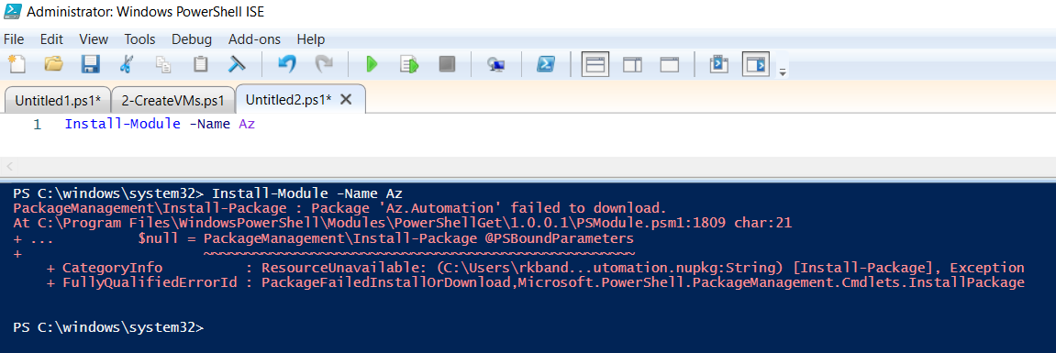

THE FOLLOWING COMMANDS WORKED FINE

Install-Module PowerShellGet -Force

Install-Module -name Az -AllowClobber -Force

= = = = = = =

#Let's login, may launch a browser to authenticate the session.

Connect-AzAccount -SubscriptionName 'Visual Studio Enterprise Subscription'



= = = = = == = = =